Project 1 Report (title)

Introduction

1. Introduction to Othello

Previous Work

Play a few round of Othello to get familiar with game rules…

Game Materials Collection.

Implementation

1. **UI design**

1.1 Home page:

In home page, a user will have three buttons to click:

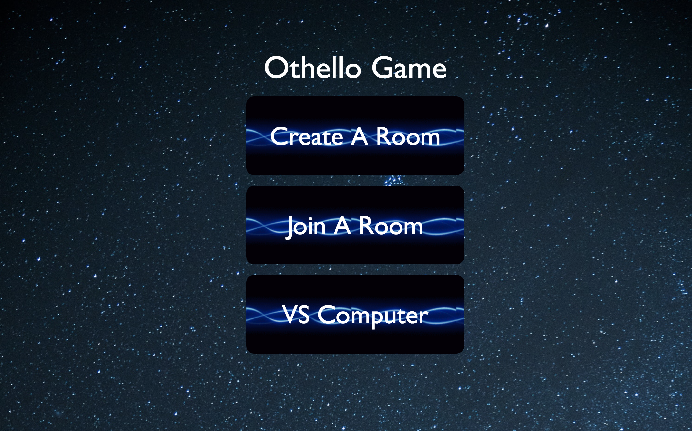  
Create a game

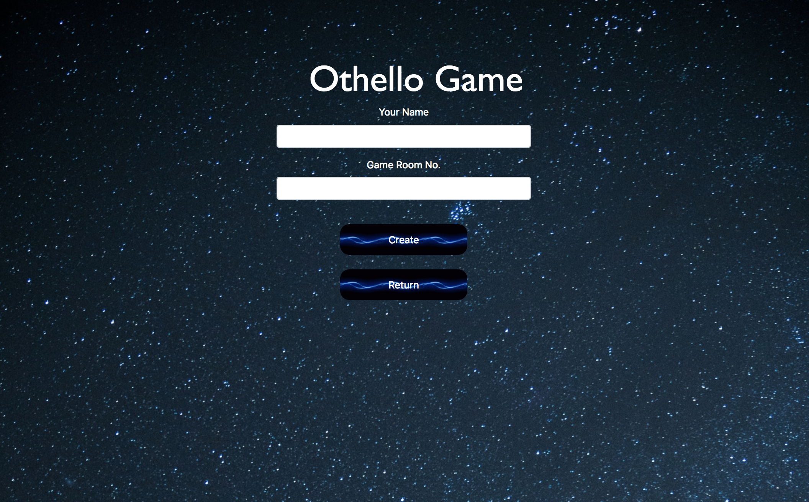

If a user clicks this button, then he needs to fill two input fields: One is user’s name, another is Game Room the user wants to create. Then the user can click create to create a new game room.

If the room exists, he will enter the room directly. He can also click the return button to go back to home page

Join a Game

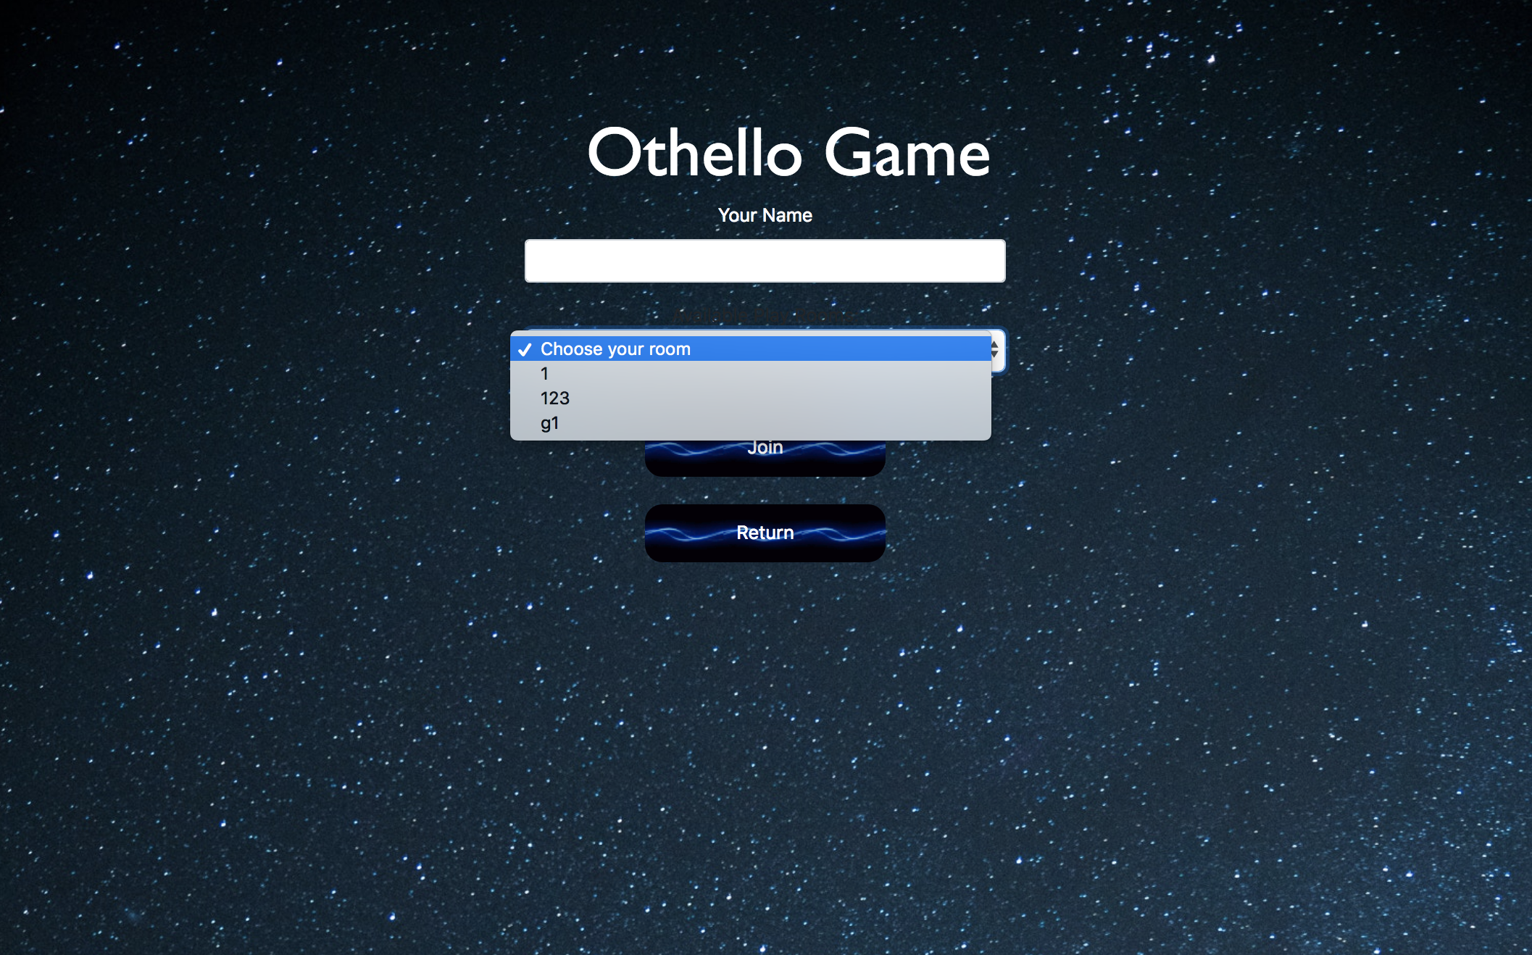

If a user clicks this button, then he needs to fill the user name and select an existing game room in the drop-down list. Then the user can click the Join button to enter a game. He can also click the return button to go back to home page.

Vs Computer

If a user clicks this button, then he will create a game with Computer.

1.2Game Page:

Topping:

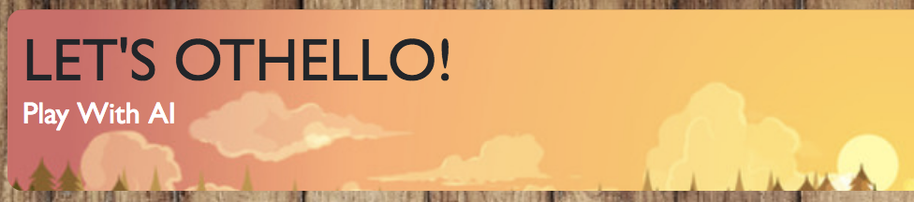

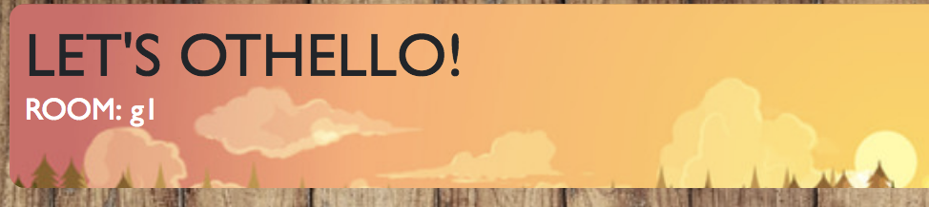

The top of game page is the room information, a user can see which room he entered. (If the information says Play with AI, that means the user choose to play with AI)

Chess Board:

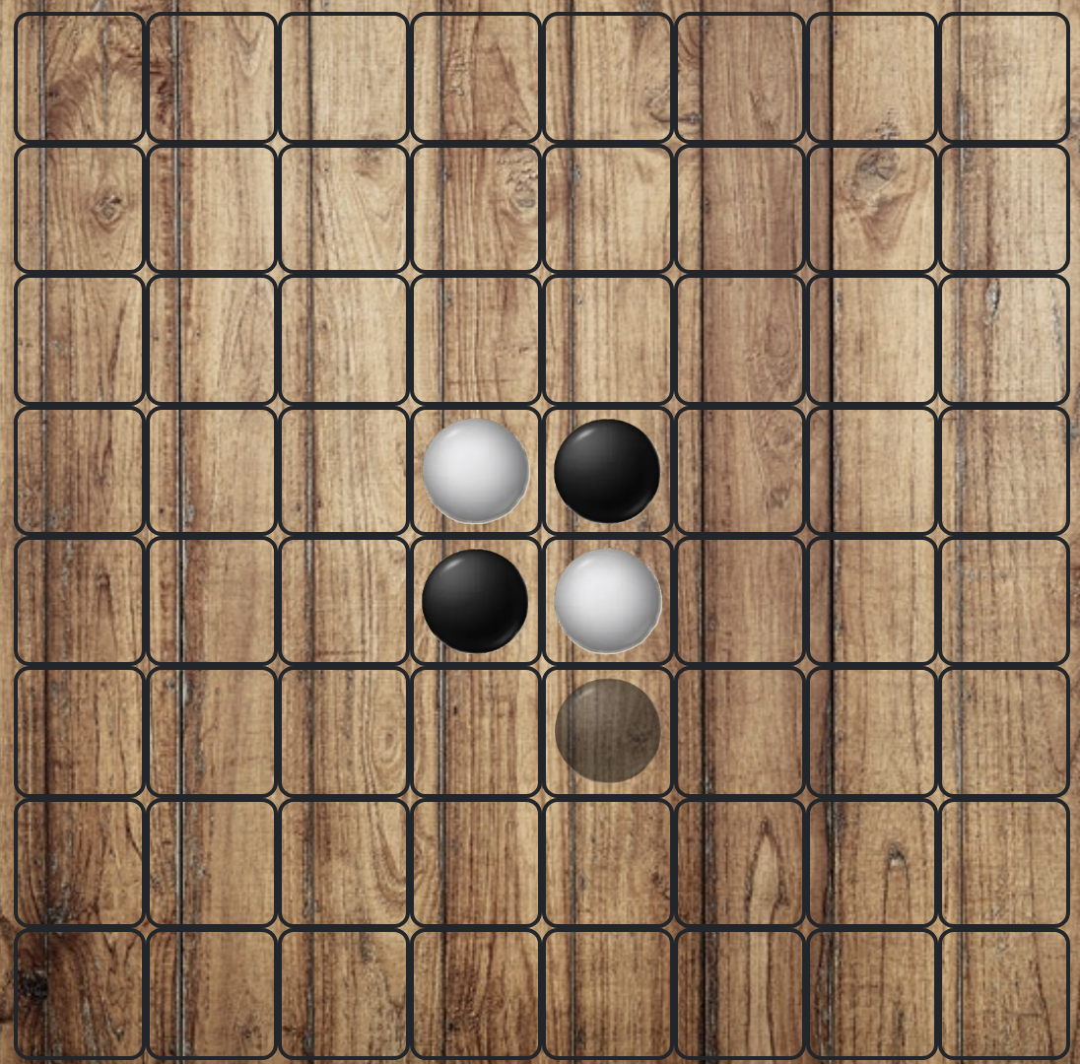

The left is a chess board. When the game starts, both players and spectators can hover the mouse on every square to see which square the current player can place a piece on. (If the square can be placed a piece, there will be a transparent piece on it). But only the current player can click the square and place his piece.

Menu:

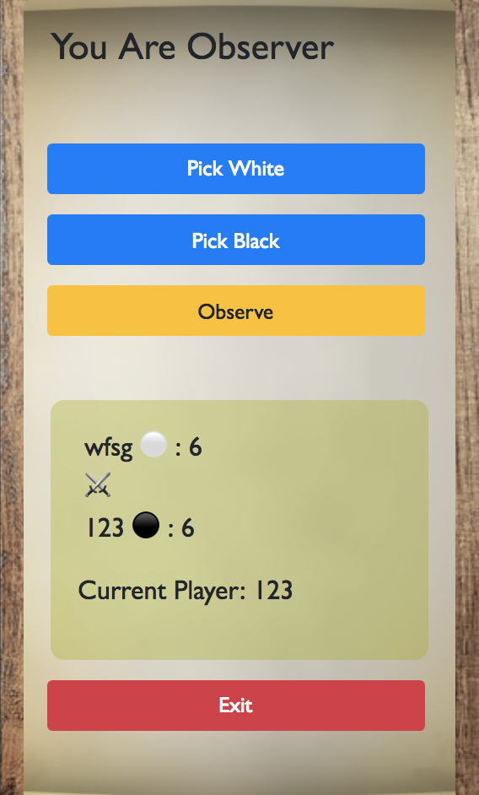 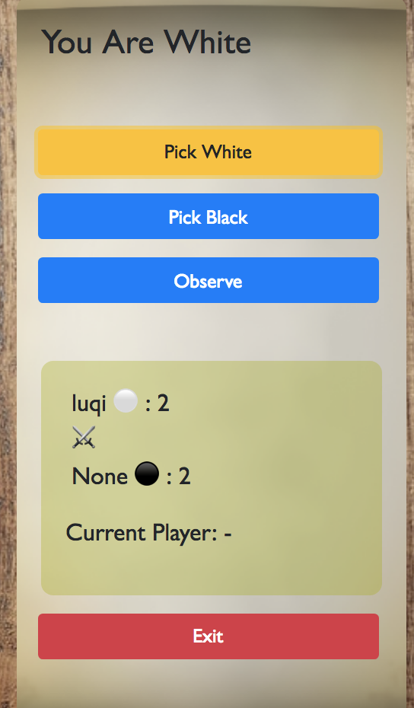

The right is the menu. On the top of menu, the user can see its state, there are three states: You are Observer, You are White, You are Black. Every user’s initial state is Observer.

Below the state is three buttons to choose user state.

Pick White: User can pick white piece to play this game. Then the button will be yellow.

Pick Black: User can pick black piece to play this game. Then the button will be yellow.

If the black or white has been picked, It can not be picked by another user. When a user try that, he will get the alter information: “Black(White) has been picked by another user!”

Observe: User choose to observe this game.

Below the three buttons is a Scoreboard:

It shows the current score of two players and which piece they picked. It also shows current player who needs to make its next move.

Below the Scoreboard is an exit button:

User can click the button back to home page.

During the game:

If the current player doesn’t have available move, there will be a modal display to tell all users that the current player doesn’t have available move.

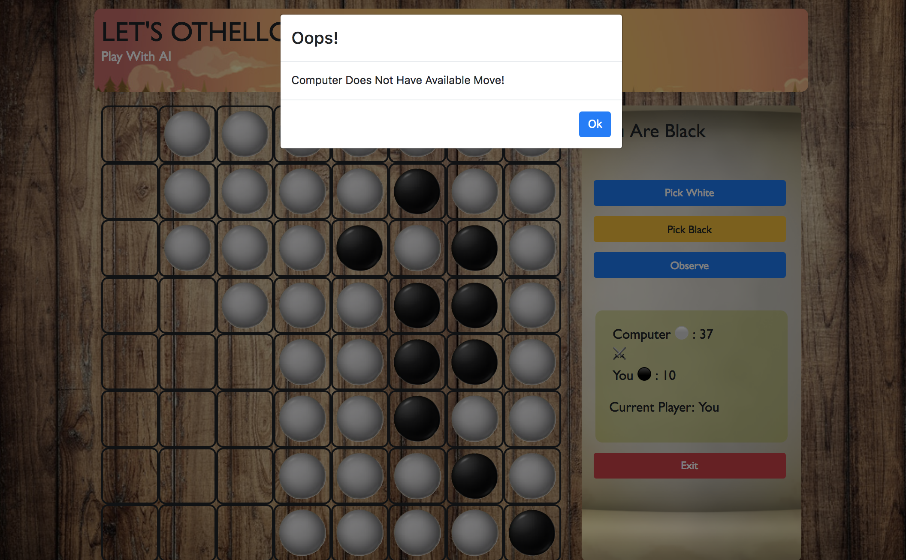

If both players don’t have available move, there will be a modal display to tell all users the game end. It will show who win the game and the final score. There are two buttons in the modal. One is Again, the user can start a new game. Another is Leave, the user can go back to home page.

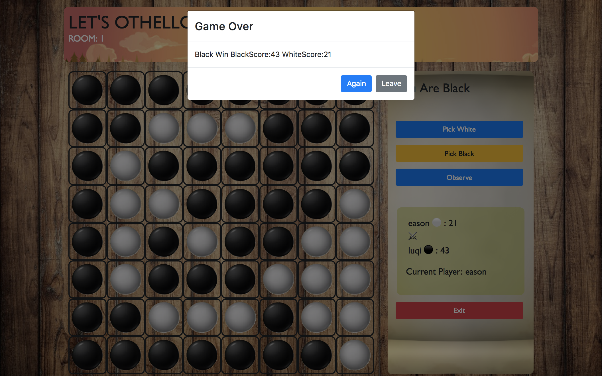

1. UI to Server Protocol

There are four types of message that client will send to server:

(1) Message Name: chess.

Payload Structure: Map {state: state}

This message is use to update the server side’s state, when the game state change happen in client side(Like user choose to pick black, white). The changed state will send back to server, the server will update the new state and broadcast to all users in the same channel.

(2) Message Name: click.

Payload Structure: Map {state: state, index: index}

This message will be send when the player click the tile and place his piece. Then the message send to server to compute the next state of game and broadcast to all users in the same channel.

(3) Message Name: aiplay.

Payload Structure: Map {state: state, index: index}

This message is used when user choose to play with computer. Every time user place his piece will send the message to server compute what the computer should do.

(4) Message Name: restart.

Payload Structure: empty

This message is to tell the server to reset the state of game. This message will be send if the game is over, and the user choose to restart game.

There are one type of message that server broadcast to client side:

(1) Message Name: chess.

Payload Structure: Map {state: state}

Every time the server’s state is changed. It will broadcast the new game state to all users in the channel use this message.

1. Data Structures on Server

Game Structure stored in Agent.

1. Implementation of Game Rules

JavaScript Game State Calculation

Game AI Implementation

1. Challenges and Solutions

Get current player on the page.

Determine if no move left.

Determine if win.

(more…)

Further Work?

Conclusion?

Reference?